Implementation Report

Teacher in charge: ROSALIE Martin

Team: Roman Empire (composed of REBIÈRE Marc and MEHAIBIA Rami)





Summary

Contents

What our game does first and foremost 3

How to play our game? 3

Before playing 3

The mechanics of our game 5

What makes our game different from the others? 8

Audio implementation! 8

Debug mode 8

Jukebox mode 9

Easter eggs 9

Discarded concepts 9

Age of the player 9

Vs computer 9

Unitary tests 9

Development phase and implementation of code 10

Creation of the first textures 10

Beginning SDL 11

Encountering the first problem: Texture traces/tracks 13

Insertion texture decision 15

First matrix representations of the game board 15

Setting up the first iterations of treasure get and movement 19

Insertion system and testing more than 2 players 21

Audio system nightmare 24

Finishing touches 25

How our repository is organized 26

Conclusion 32

# What our game does first and foremost

Let us begin with the actual mechanics of our Labyrinth Game. It has only one type of play: Multiplayer. The reason as to why we couldn’t do computer will come in a second. But first:

## How to play our game?

### Before playing

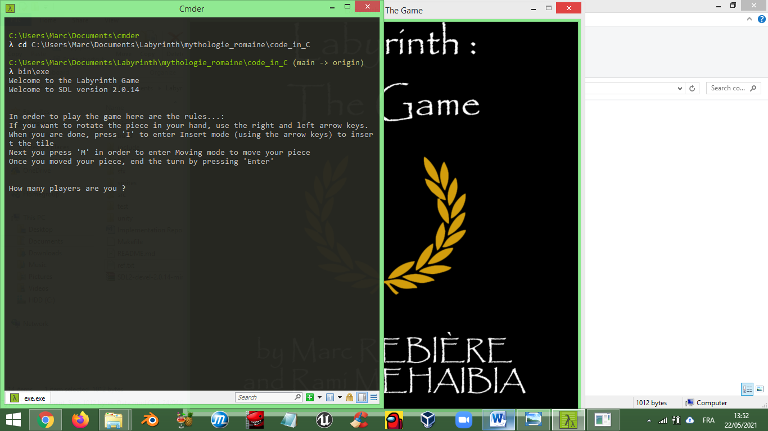 At the beginning, you are asked to input the number of players for the game. You can only choose between 2, 3 or 4. If you put any other number it will ask again until you give the correct number.

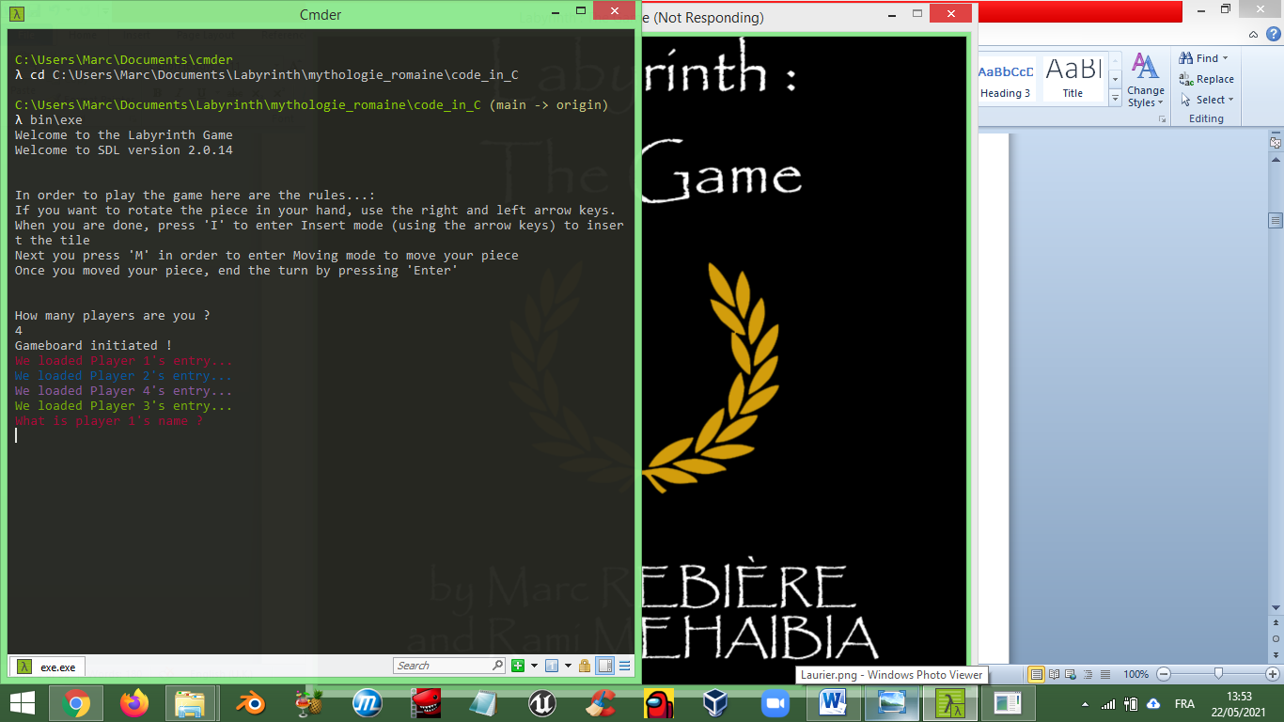 After that, it will ask the names of each person. The order will always remain the same: Red goes first, then Blue, then Green and finally Purple (they represent Players 1 through 4 respectively).

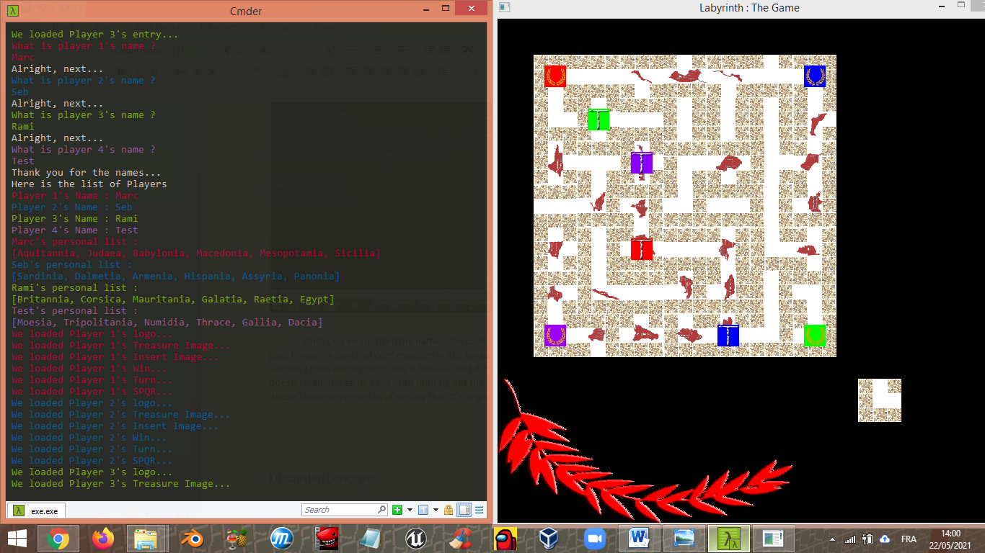Once you’ve inputted the names, the code will load the players’ texture and the game. It will pass through a bunch of confirmations in SDL language that the loading of a texture worked (since we don’t have unitary tests, this is how we test if it works). In the eventuality that some texture doesn’t load, the game exits itself printing out the error and its location in the code (but since it doesn’t have any errors as of writing this, it’s alright).

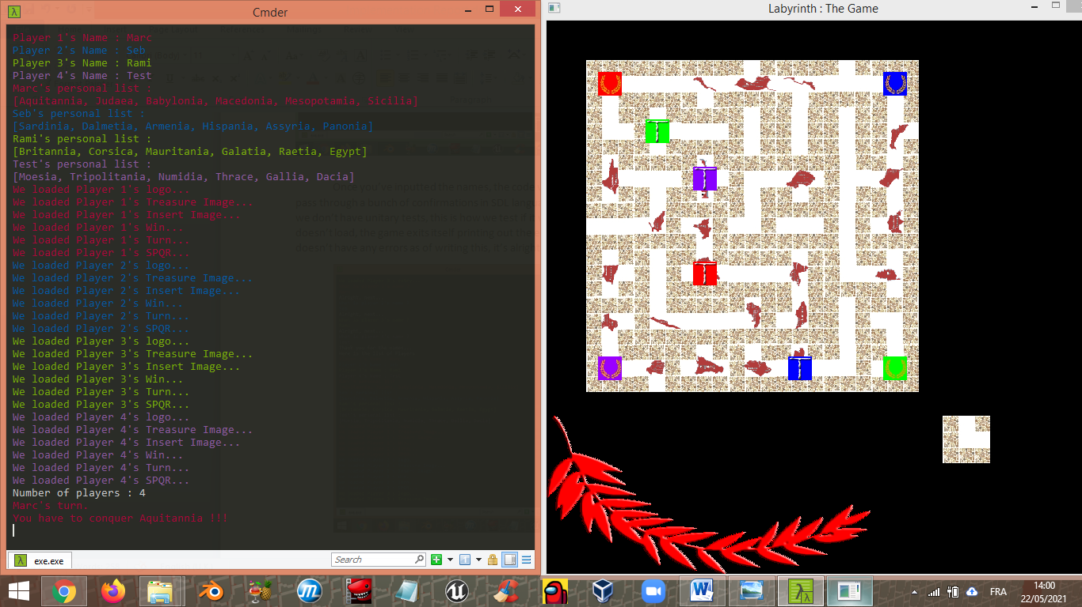

Once everything is loaded, you can now play the game!

### The mechanics of our game

Now it’s Player 1’s turn. By default, you are in “rotating the piece” mode, where you rotate the outside piece. To do that you just press the right or left arrow keys. By default the Outside tile is either in the basic I shape, L shape or T shape.

Once you chose your rotation now you can enter the “insert” mode by pressing the I-button. A sort of cursor will be automatically set up on the top left of the game board which will bear the respective player’s colour. To choose where you want to insert your tile, press the left and right arrow keys. When you’ve decided where to insert the tile, press the M-button in order to enter “move” mode. But here are some little titbits before moving to the moving section: If a player is pushed outside the boundaries of the game, don’t worry because he’ll reappear at the opposite end of where he was pushed out; if a treasure is pushed out, you can still see the treasure on the outside tile; and finally the player doing the insertion cannot replicate the same move as the previous player backwards (for example if I push down on column 3, the next player cannot push up on column 3). Note that the tile that gets pushed out will always return to its basic shape (example: if we push out an L-shape oriented towards the right, it will be outside as a normal L-shape).

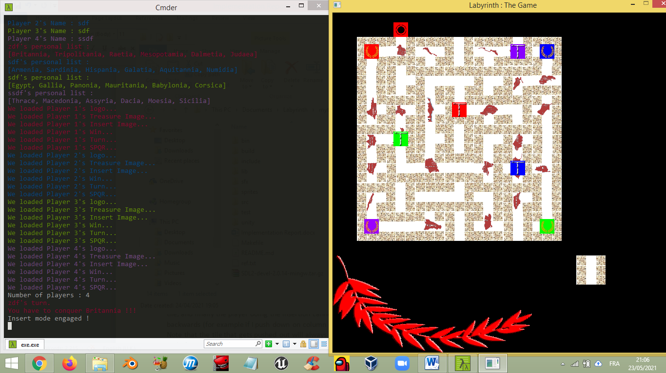

For the moving portion, you use the arrow keys to navigate inside the map where you can. You cannot teleport from one end to the other (for example if you are on a right most end tile with an access to the right and to the left most end there is an access to the left, you cannot pass by going out of bounds and teleport on the left). Here in our game you get to move the pieces, just like in a real game of labyrinth, instead of teleporting once there is an access to a treasure. It’s all about access here, if there is a wall, you cannot phase through it magically, if you can, then that means that we screwed up our code somewhere (normally we did not).

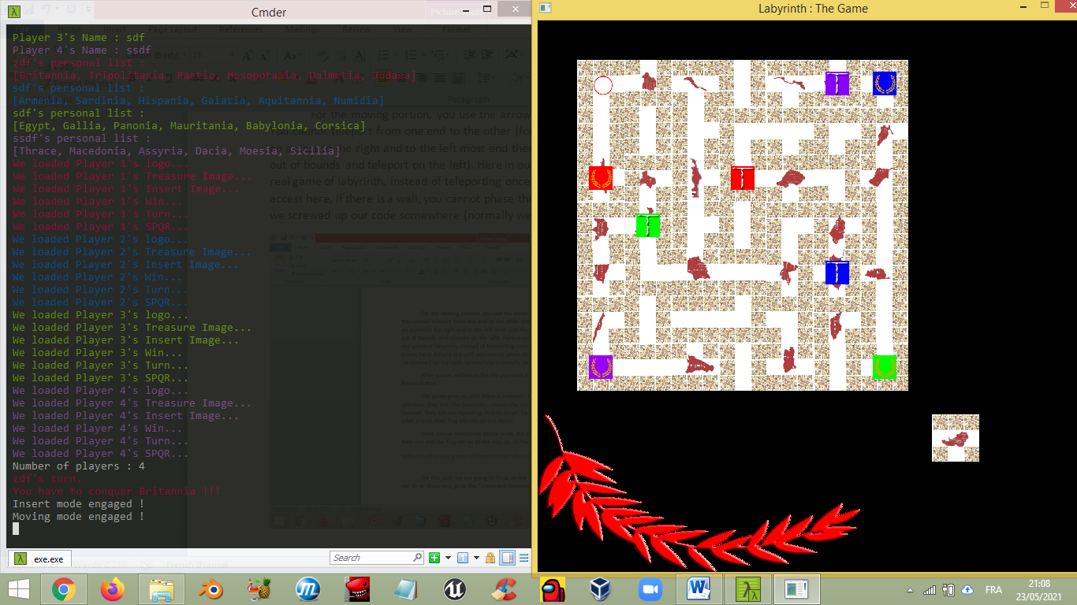

After you’ve settled on the tile you want to remain, you can end the turn by pressing the Return-button.

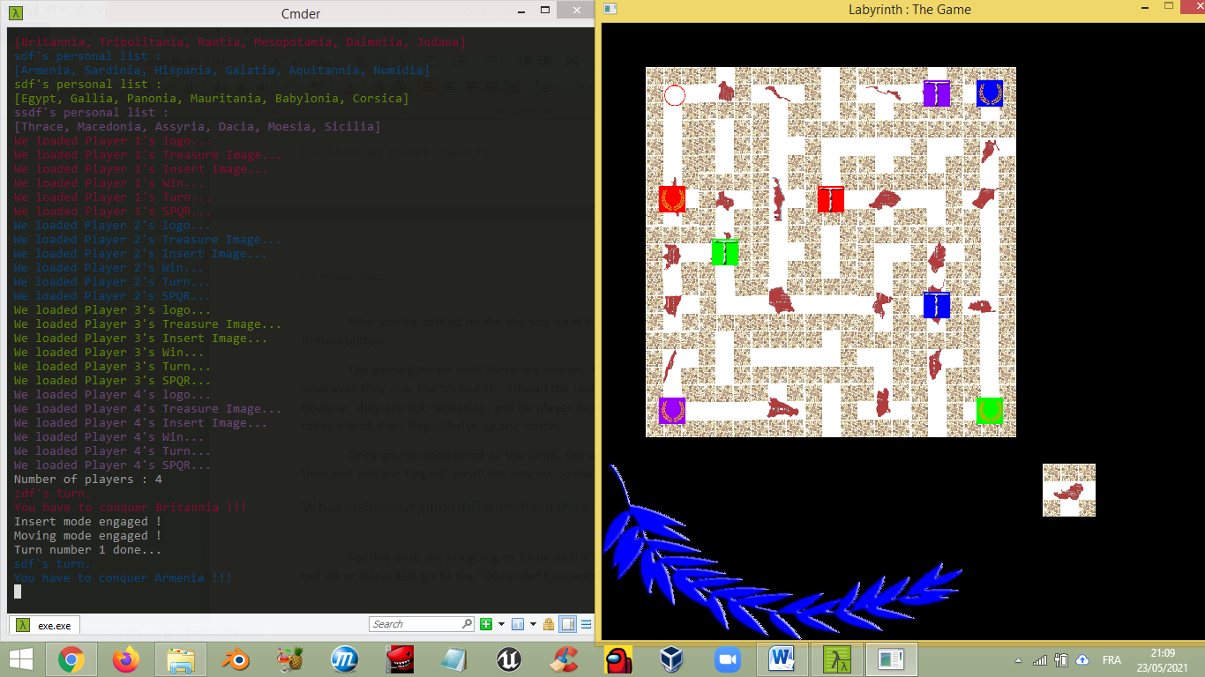

The game goes on until there is a winner. The treasures will always update and show up wherever they are. The treasures… I mean the lands to conquer, are given at random to each player, however they are not repeating, and no player has the same land to conquer. Also, when a player takes a land, their flag will rise up one notch.

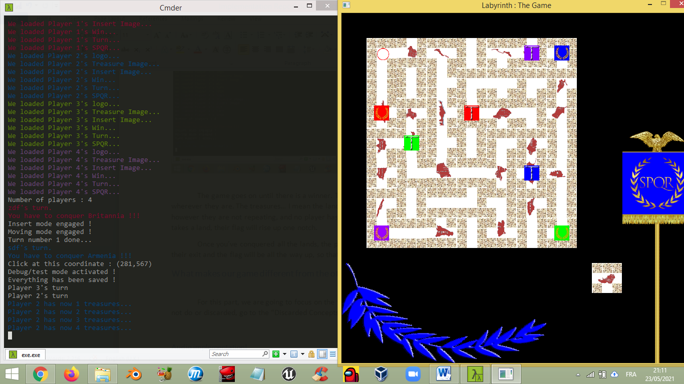

Once you’ve conquered all the lands, the player’s respective treasure icon will appear on their exit and the flag will be all the way up, so that you can go back home and tell your tales.

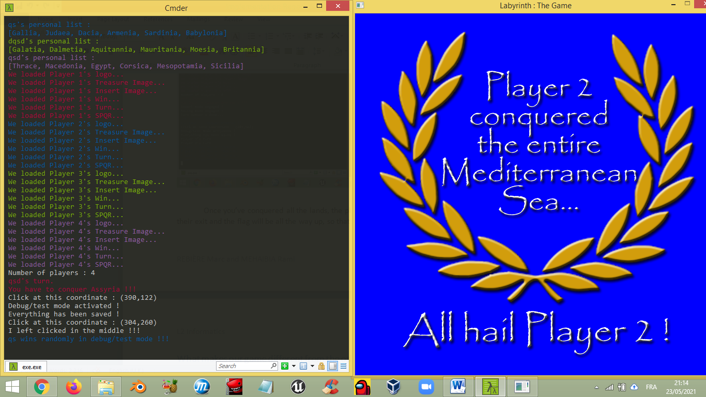

## What makes our game different from the others?

For this part, we are going to focus on the things that we added, for the things that we could not do or discarded, go to the “Discarded Concepts” section.

### Audio implementation!

I think we might be the only group who implemented that… If there are others, shame on us for not knowing. But here is the thing, all the audio was made manually, by yours truly.

For that we used a nifty program called “Famitracker” which is a NES music composer. In it we’ve made all the sound effects (that you can also find in the folder sfx, but that would be cheating).

It took one night without sleep to understand how SDL incorporates audio, but in the end we managed to put it in, hopefully you’ll enjoy this feature to make the adventure even grander!

### Debug mode

If you press the D-Button, you get to access our little Debug mode, which was used to check the flags rising up and the good implementation of the turn system (represented by the coloured laurels and the rising flag of each player).

When you are in the Debug mode all the game data is saved so that you may go back once you’re done playing around with the flags or turns.

To raise or lower the current player’s flag, press + or - on your number pad.

To change the turn press * or / on the number pad.

To go back to normal play, press D again.

### Jukebox mode

It’s exactly how it sounds like! A whole jukebox to play your favourite sound effects in the game, because why not? To access this mode, press the J-button.

Once in said mode you can press the numbers 0 through 9 and also space as well to listen to the magnificent and crisp audio to get that retro feel.

When you are done, just press J again.

### Easter eggs

You thought that in this implementation report we were going to talk about every little thing? Well no, and that’s where you come into play… Find out the other secrets in the game, or you know… just read the code and then try it out!

# Discarded concepts

Now for the discarded concepts from the analysis report up to now. From what we have gathered, there are 3 main things that we have discarded.

## Age of the player

In the end, it would have been too complicated to reorganize each and every time the players when they have put their names and ages, so we just abandoned the idea altogether. Instead, it is first come first served.

## Vs computer

As you saw, we have a movement system in place, and that very same system is also the thing that does not let us implement a computer into our game. Why? Because we have to give random movements to a computer, alright that might be possible, but the main question is how long does the computer do that? Plus it may glitch or something, so that would have been disastrous. Instead we chose to develop something that would make our group stand out (hence the audio system). By the way, the choice of putting audio was in the middle of development after hearing that SDL was capable of doing that.

## Unitary tests

Alright… The main discarded concept… Here is the thing: the SDL library provides functions that give you when the error occurred. In addition we always have if statements implemented to test out that if a function returns NULL or 1 (typically the error return values) we would print the area of the code where we had the problem, and we would exit the program. As for why we could not do it with unity, well it’s because we would have to test out each function all over again, which we already test anyway whilst building the game. For you see, if the game crashes, we would know where and how it crashed. But since now it doesn’t crash, that means that everything is going according to plan. Therefore we have decided that it would not really be of any use to test things that we already test when building the game.

In conclusion we can say that we have discarded a few concepts along the way but we have basically applied the majority of what we wanted to do in our analysis report, and some more things along the way.

# Development phase and implementation of code

Now, for the moment you have been all waiting for… The DEVELOPMENT PHASE!

Let me tell you, it was hard, we worked 5 days straight on this one, at least 10 hours each day, and one night without sleep plus other nights where we worked until 4 in the morning. Those 5 days were true hell on Earth, from Saturday 24th of April to Wednesday 28th, for the main concepts, textures, sound effects, code implementation, trials and error and everything in between. As of writing this, we worked a bit here and there to polish it a little more, but nowhere near the amount of work that we did in one sitting during that period. Even though I remember the dates of work, I don’t remember what we did on each day. However I have a ton of images of the development in order of what we did. Therefore this part will be cut in several subsections in order to explain how we did things (visually speaking instead of putting the code and to just leave you to decrypt what we did). Also as a quick mention, in the end we did 4 C files for this project: audio.c which has one audio function that we’ll describe later on, begin.c which has functions that take care of creating the players, middle.c which has functions that take care of creating the game board, and finally main.c which is the code that has the most number of lines… more than 2000 to be exact. Why is that? Because essentially everything happens in there: the creation of the application, the building of the textures, **the game loop**, the freeing of everything after you are done playing. Everything is done there in one go. It is no joke to say that we stayed a long time doing this game.

Now we can get onto the development phase!

## No description available.Creation of the first textures

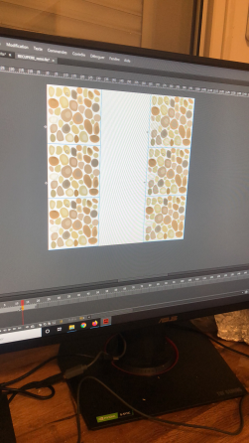

We had a pretty slow start to begin the project but in the end we began to think up of our game design first and foremost. We went through multiple concepts for the tiles before we decided on a final design (which was in the end something reassembling a paved antique road). We even had one that we lost, which was basically a T-shape with the walking path represented by a red carpet with yellow limits and the walls were purple. Note that the majority of the textures were done by Rami while I was figuring out how SDL worked later on.

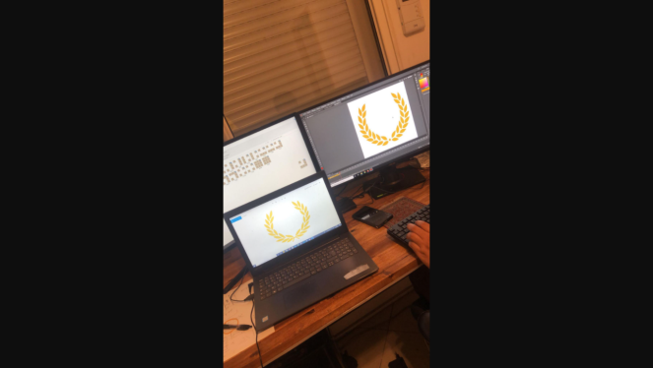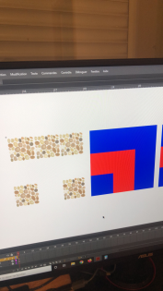

 As for the players it was almost instantaneous, we knew that we had to represent the player as a Roman Emperor while still keeping the design simple and basic. There are still some unused player colours though, because we chose multiple colours to test out which were eye-catching. In the end we chose to go for the classic RGB with my little touch of Purple for the fourth player.

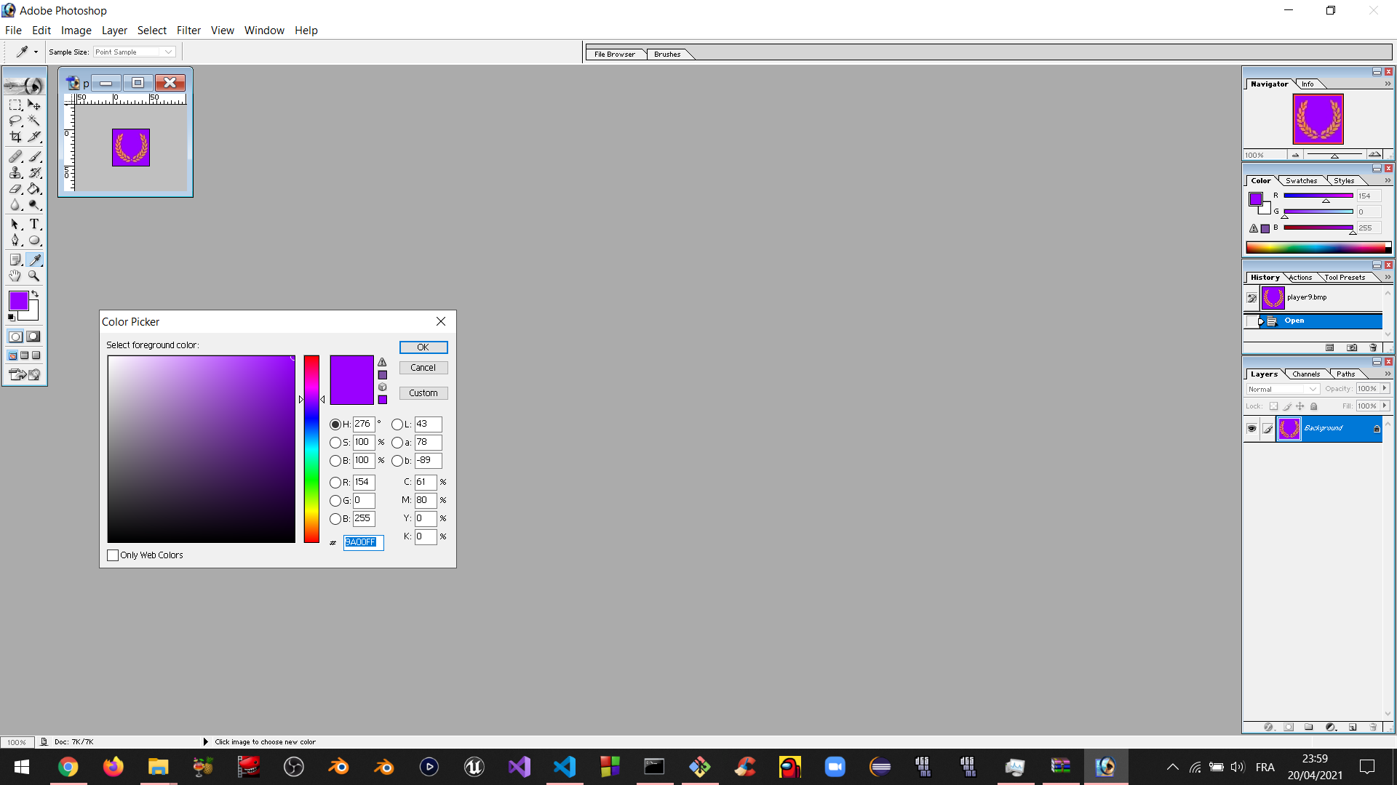

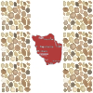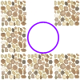After that we moved onto the special tiles: the land to conquer tiles and the exit tiles. Since we did not know that I-shaped tiles couldn’t have treasures we made 24 more than expected and are still in the folders, and are therefore unused assets. As you can see all the tiles are by default in their default shape, because we change their orientation in-game, thus minimizing the amount of sprites we need to do.

## Beginning SDL

At the same time, I was beginning to learn how SDL worked. I understood several things:

* How to initialize SDL
* How to create a window and a render
* How to set up a colour
* How to draw a point
* How to draw a line
* How to draw a rectangle (and at the same time how to make one)
* How to close a render and free everything
* How to check for errors
* How to present the render (because you have to present it every time you make a change or when you add something at some coordinate it doesn’t magically show up, you have to present it after the change)
* How to delay the render
* How to make a game loop (even though there was no game yet)
* And finally, how to import a BMP file in the render (and yes, only bmp files work apparently)

To actually import a bmp on your render you had to first create a rectangle. The SDL rectangle is a struct that has at least four main variables to know by hear: x, y, w and h. w and h stand for width and height and we will cover them in a second. x and y are the coordinates but they begin from the top left of the render window thing. So if you put x=0 and y=0 well your image will be rendered on the top left but not centred, but by its top left corner as well.

After you have made your rectangle, you need to create a surface and a texture. A surface is essentially a struct that will let you import the bmp file and the texture is going to take said surface so that we can manipulate it as we wish. After we’ve attributed our surface to the texture, we don’t need the surface anymore. The texture will then pass onto the rectangle with the width and height attributed with a function (when you see the code you will understand) and voilà: we can manipulate the rectangle. Now I know, this is just the tip of the iceberg but that is how it works in broad terms so that anyone can understand.

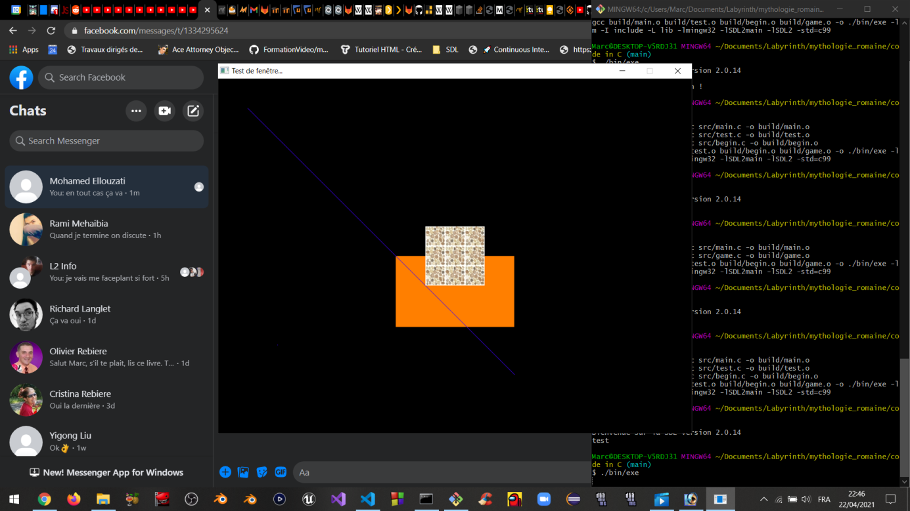After messing around a bit with the functions (first image), we decided to have a clean slate and a blue background (second image). By the way, you can also rename the window (we just named it “Test de fenêtre…” because we had no inspiration) at the time.

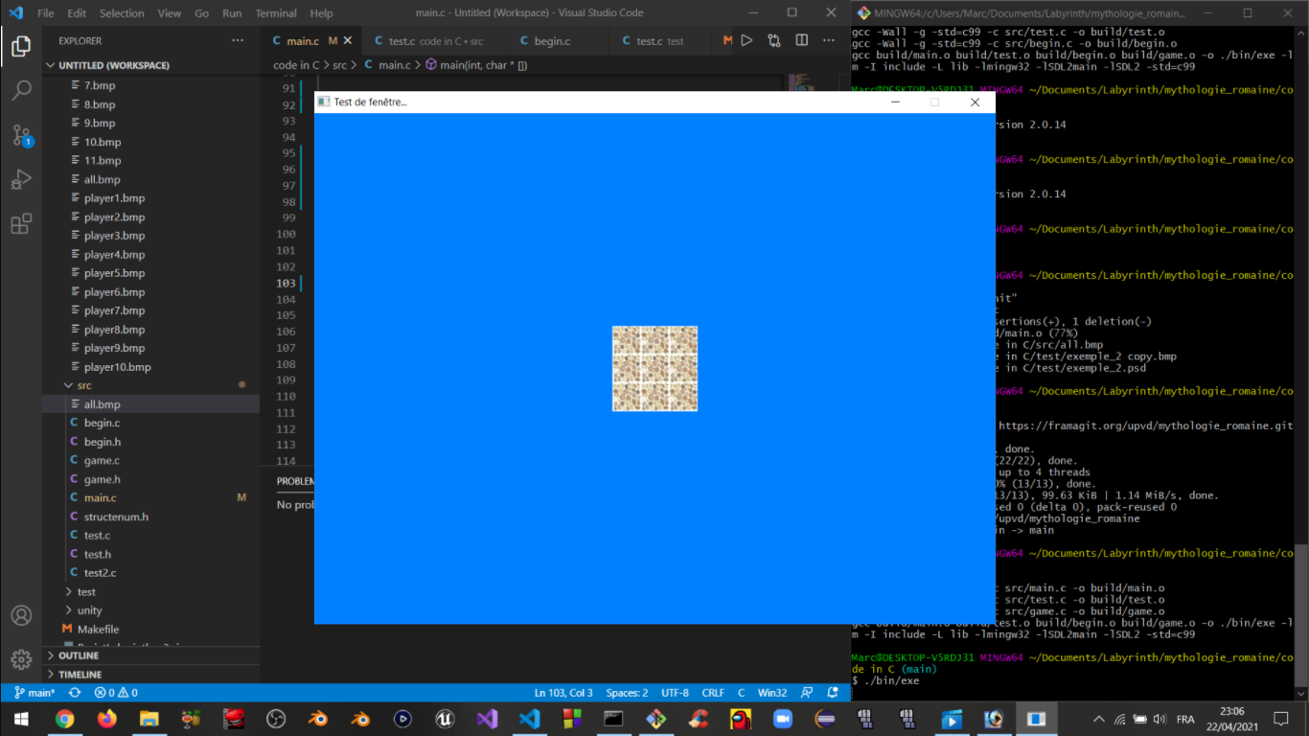

Also you see... game.c was the file where we tried to make a functioning labyrinth on the terminal. In the end we just abandoned it and deleted it further down the line.

## Encountering the first problem: Texture traces/tracks

After having succeeded in importing the first test texture (void of logic), now was the time to get started onto the great battle: MAKING THE GAME!

First and foremost we had to put in the players (and the amount of them would depend on how many you wanted between 2 and 4). After that we had to make them move on the game board somehow, and with limitations (and yes even though there was no game board there present). Therefore the first rule that the player must have automatically is: Do not move more than 7 spaces (please). And you see, each player (which is also a struct by the way) had a position. Player 1 would spawn at (0,0) (but then converted into the coordinate system of the render), Player 2 at (6,0) (because x,y and not i,j), and so on and so forth. You see, the player would not be in the actual matrix of the game board. The player “hovers” over the game board with a coordinate system compatible with the matrix! Now, we have set the basic limits of the player to not move more than 6 or less than 0. That was nice and good But then, we would hit the main problem:

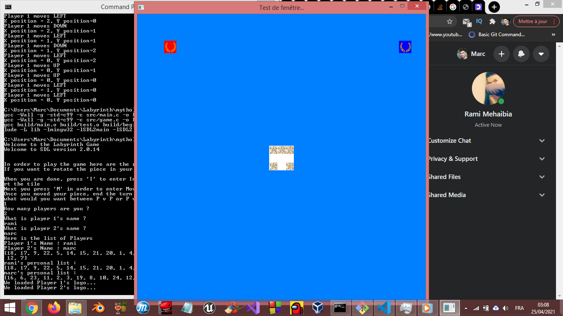Before:

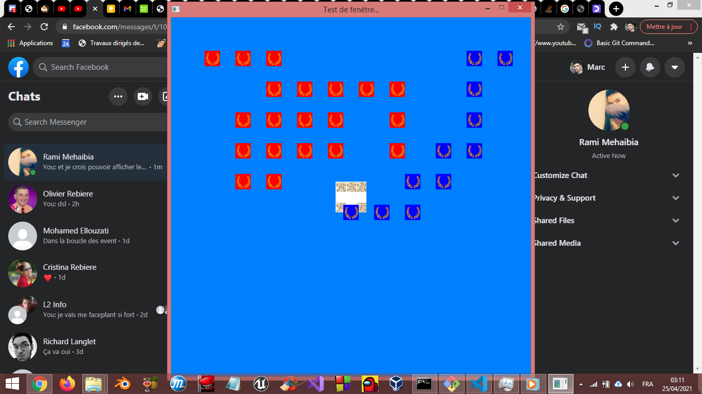After: (also don’t notice the fact that I set up the limits wrong)

So you see… the problem was that the render was like a piece of paper: You draw things but they don’t magically go away, you have to present a new paper of the modification, and therefore render all the textures again in order (which was doable since we were able to make the game).

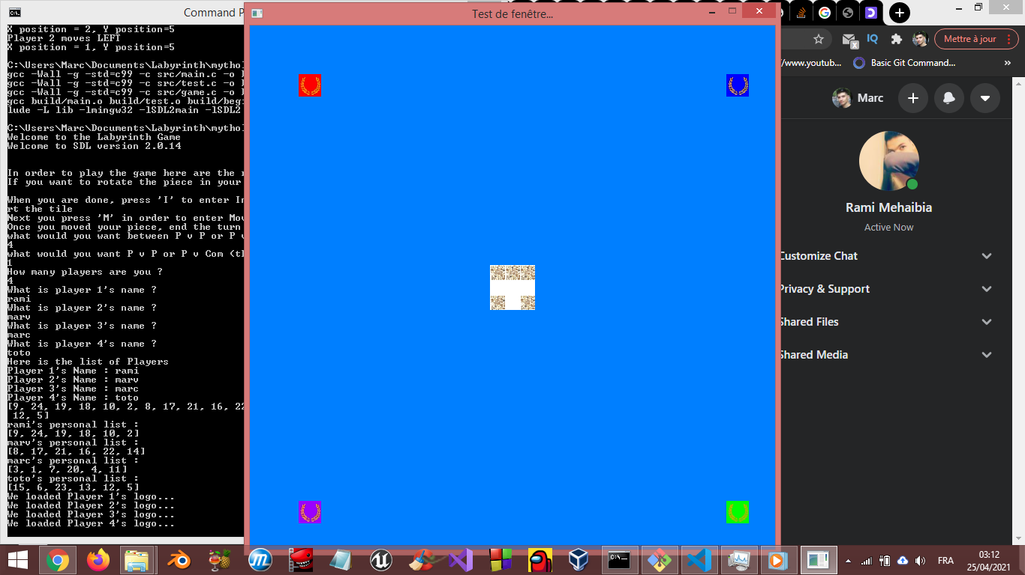 And that is what we did later on. Also here is an image of 4 players at once in early… game I guess?

## Insertion texture decision

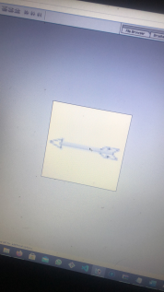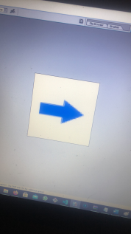

 Before we could render a huge matrix, we also had to settle on which insert texture we wanted. We made several of them, but ended up choosing a sort of bullet point, so that we don’t have to bother with where the arrow would point towards! Sometimes simplicity is key!

## First matrix representations of the game board

Now for one of the more complex things… the game board itself.

Let’s first establish several things we did in the meantime. As we wrote in our analysis report, we wanted a structure for a tile, for a player and for a game board. And so we did just that!

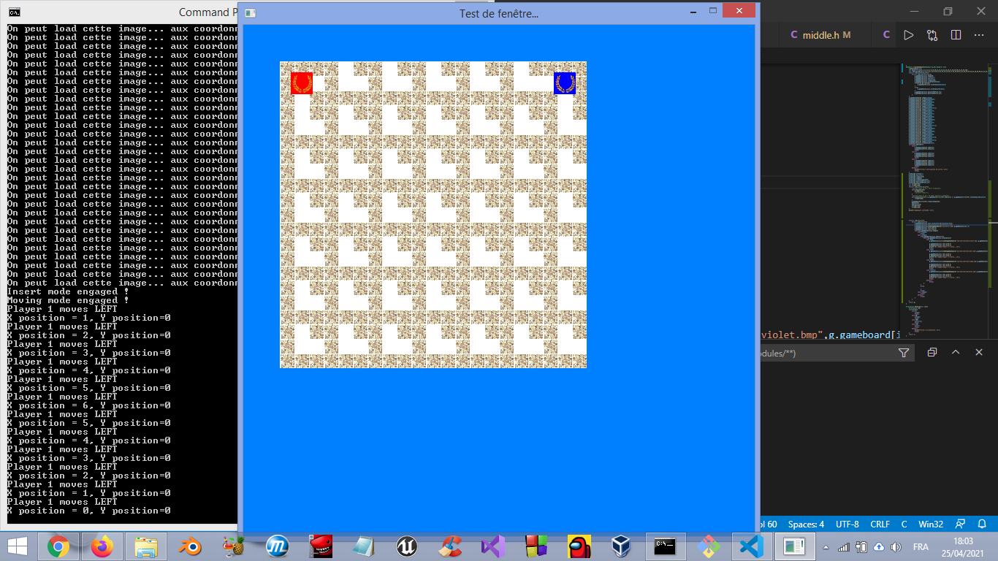The player struct is separate from the other two whilst the game board structure has a 7 by 7 tile matrix. A tile structure has rectangle, texture and surface variables. By default we loaded the L structures to test them out and they are placed on the render based on math that you can find in the code, but the result is impressive:

Yes a matrix full of Ls… That was only the beginning.

Next step was to set up the unmovable tiles. We took a page out of the Yugioh group in order to ease our pain. The treasures 13 through 24 were going to be the unmovable tiles. While we are on the subject of the Yugioh group, we were greatly influenced by them in the beginning because they did everything in SDL before us, and with their consent we looked on their code for clarifications on certain things, without copying of course, just to have a reference point on how to first set up SDL, liberate the stuff at the end and this. They were a great help and we thank them from the bottom of our hearts, because we would not have made this much progress without their help. Of course, in return we helped them in other projects or works.

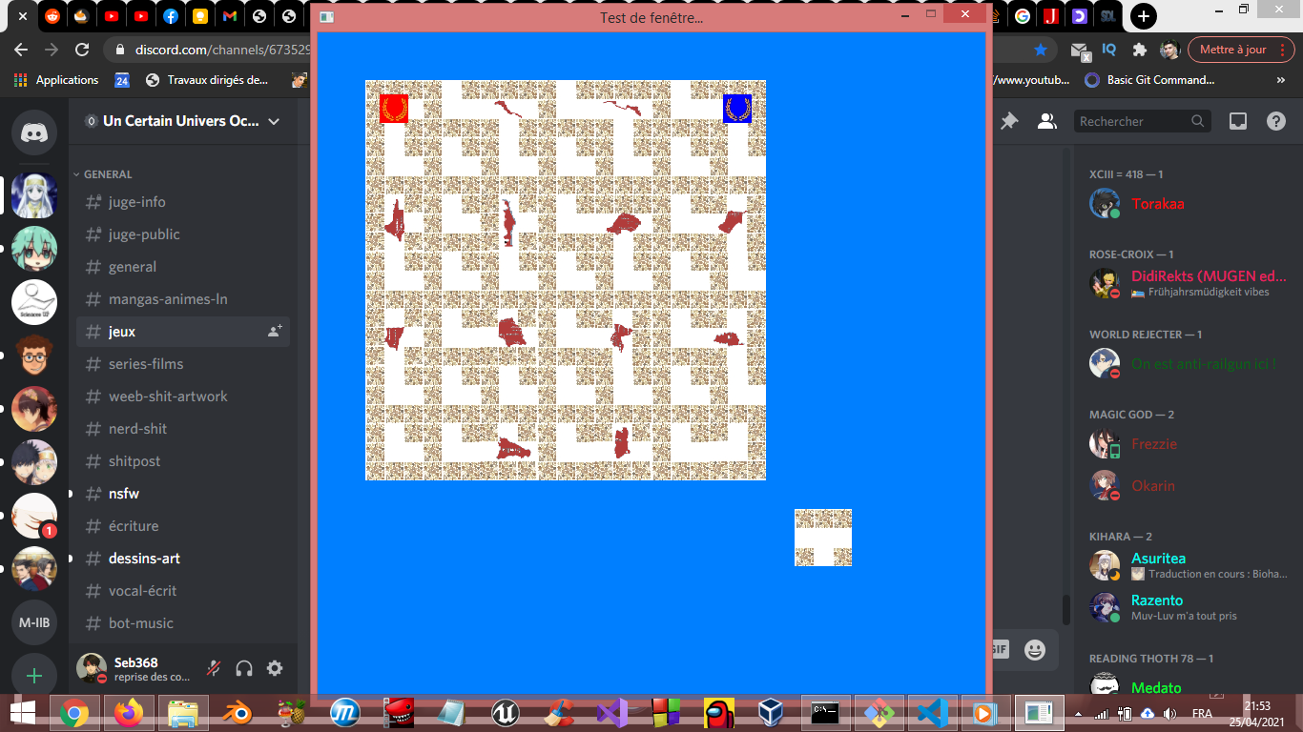But back to the topic at hand, we selected the treasures 13 through 24 and have imputed them in the matrix, and the result is below: (also the tile at the bottom right isn’t the tile outside of the game, it was still the first test tile, we were trying to place the future outside tile in a place pleasing to the eye and to plan for it we tested our test tile in a pleasing position)

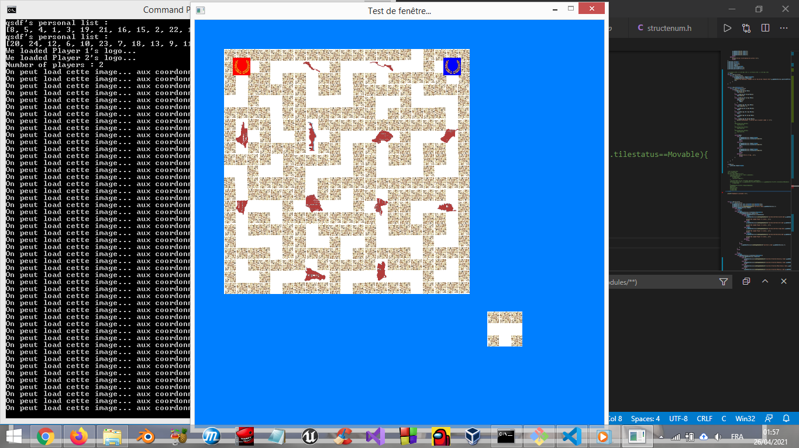After this step, we made the necessary adjustment so that the movable pieces would have random orientations:

Once we were done with that, we took out the placeholder for the outside tile, we put the remaining movable shaped tiles (with the same proprieties as before) onto the game board and then inserted the treasures 1 through 12 randomly (with the I-shaped tiles not having any treasures).

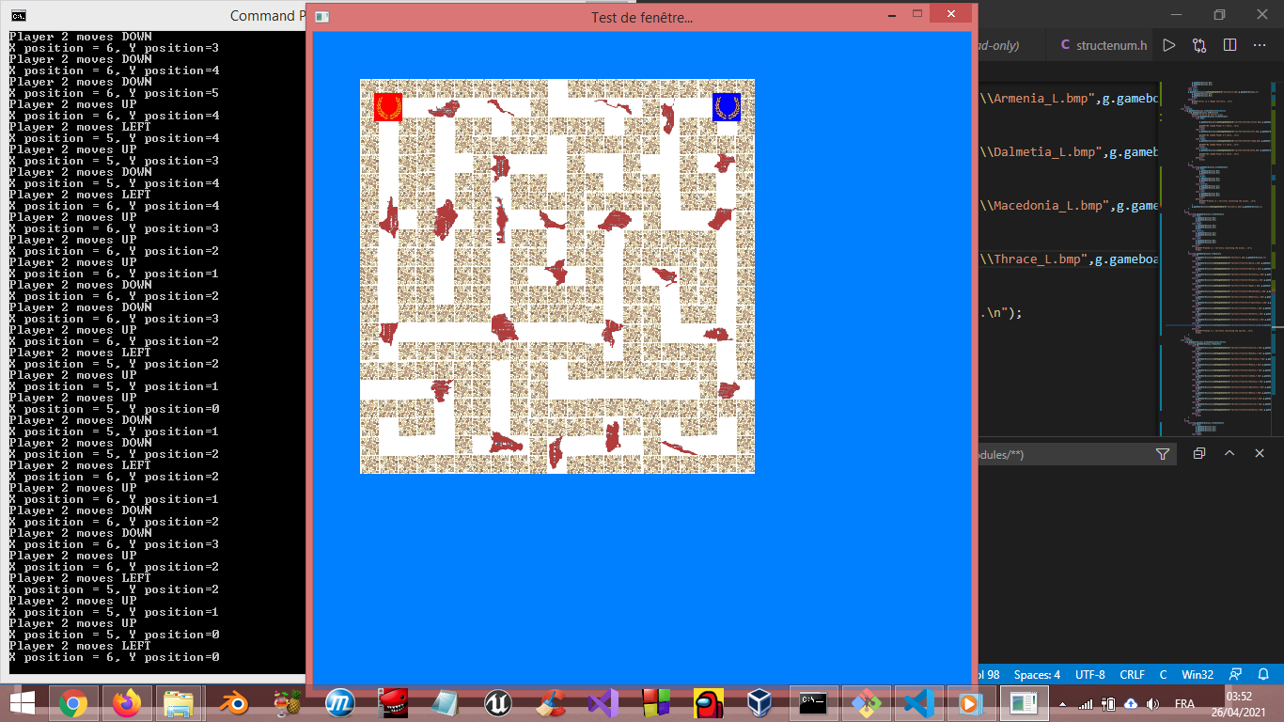

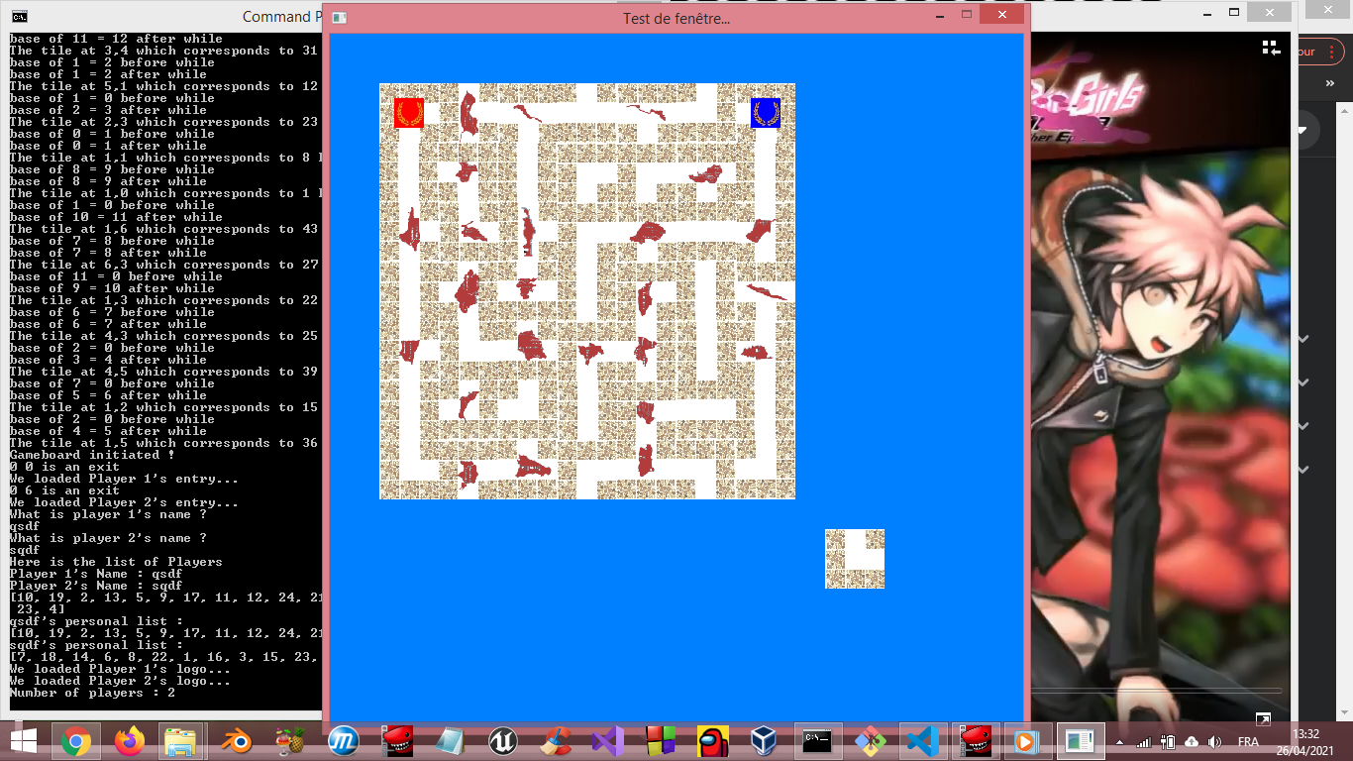 Then, came the first iteration of the Outside tile, which by default was an L-shape for testing purposes:

## Setting up the first iterations of treasure get and movement

After having succeeded in setting up the general game board, visually speaking, we needed to compose the logic behind the way of moving around. Let me explain: Right now we can “phase through the walls of the game” because we are only restricted by the earlier rule of “don’t go over 6 or below 0”. Therefore we created a switch on the beginning functions in middle.c that would define the first accessibility points for each tile depending by their shape and their orientation. For example if I have an L-shaped tile, the accessibility would be N=1, S=0, W=0 and E=1, meaning that we can go North and we can go East. And this process is done before we load the images, and the unmovable tiles are done manually beforehand while the movable tiles are done after we determined which type of tile goes where and what its orientation is. After we did that, we needed to add a new rule for the player for each case (aka if he goes up, down, left or right). Let’s take an example: the new rule added for going left is “if we can go left from the tile we’re on AND if the tile on the left can be accessed to the right, then we can go left”, coupled with the previous rule we had now an efficient way of going around the map without any bugs.

The next step was to implement the system of getting the treasure.

But before talking about getting the treasure we need to talk about how we actually give each player their list of treasures to get. We have a function that has a table of 24 integers from 1 to 24 and it returns a table reorganizing those integers randomly without any repetition. These are in fact all the treasures rearranged randomly. After that we have another function that takes that reorganized table of treasures and the list of players and then gives a part of that treasure table depending on the amount of players in the game. If we have 2 players, we give the first 12 reorganized treasures to Player 1 and the 12 next to player 2. For 3 players, it’s the first 8 for P1, second 8 for P2 and third 8 for P3. Same goes for 4 players. So instead of actually having the treasures themselves we have their numbers given to each player. Now, each player has also two special integers in their struct, the first one is the treasure number going from 0 (yes 0 not 1) to the total amount of treasures they have, the second one is the total amount of treasures they have. Each time the player gets a treasure, the treasure number goes up and it identifies the next treasure the player has to get. Once the treasure number is equal to the total amount, the player has to go back to his or her starting point. How does that tie back to the game board then? Well here is the thing, I already mentioned that the unmovable tiles are given treasures 13 to 24 and that the movable tiles are given at random treasures 1 to 12, what I did not mention was that it was given to an integer that is also part of the struct of the tile. If the tile had no treasure, then that integer would be equal to 0 else it would have the treasure number, and that lasts for the entirety of the game.

Now we can talk about the system itself. Every time the player moves, we would check each tile again and update the textures accordingly. We test several things. First we test if the player’s treasure number does not equal the total amount. If it does then we check if the current treasure that the player has to get is equal to the one on the tile, then spawn the treasure image of the player at this tile specifically. Else do nothing. However, if the player’s treasure number does equal the total amount, then spawn the treasure image at the starting point of the player. That’s for the checking, now comes the “get the treasure portion”. If when the player moves, his position matches the one of the treasure, we have to increase by 1 the treasure number, else do nothing. Later on we found out that this check-up system worked like a radar, and therefore had a bug if this scan was executed only once. At the beginning, the scan was done from up to down. If we arrived at the treasure then the next treasure would not necessarily spawn. It depended on the location. If the new treasure location was down from where the player is then it was fine, it would spawn, but if it was up, then it would not spawn until the player moves again and restarts the whole check-up process again. That was because the scan already scanned the tiles up from where the player is. Therefore we needed to do this check-up twice for each time the player moves, so that we would not miss the next treasure location. Of course, if the treasure number of treasures equalled the total amount, then it would spawn at the starting point of the player, but once the player reaches that starting point, what would happen? Well in the first builds of the game it would just end the program and that was it. In the later builds… well you just have to continue reading to find out. Here are three images showing the two systems in action (the first being the treasure showing and the other two the treasure getting).

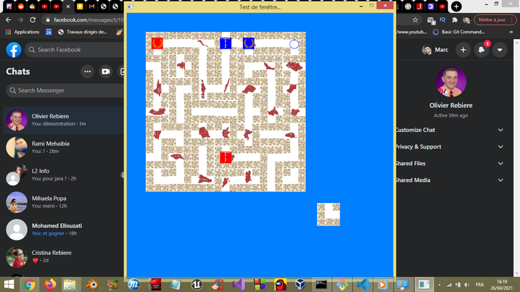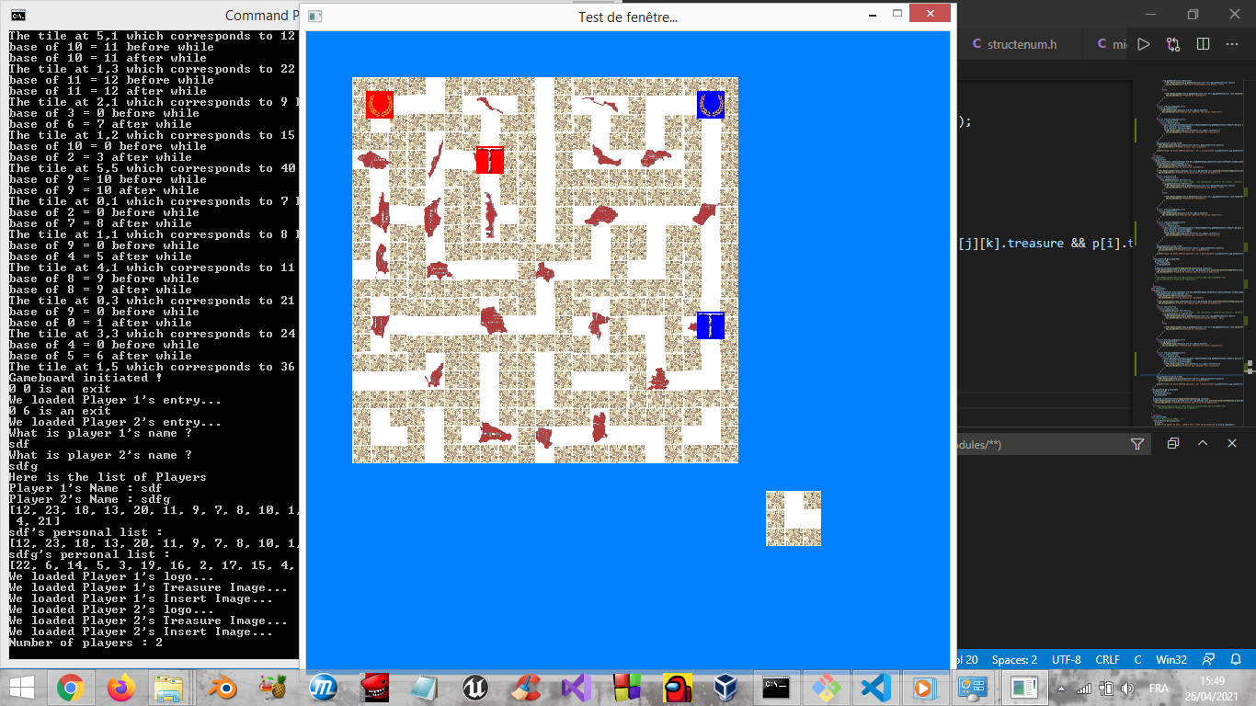

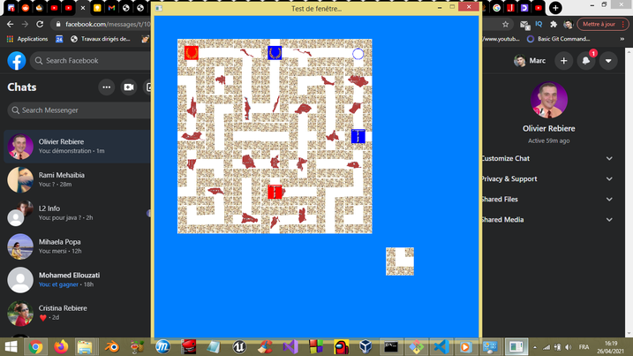

## Insertion system and testing more than 2 players

It’s all well and good that we manage to move the player and get some treasure, but now we have to actually play the game, and therefore we need the insertion system to be put in place. We already have the textures for it, we just need a clever way to use them.

To tackle it we needed to implement multiple things:

* The outside tile
* The insert locations
* The insert exception
* The change of the tiles.

We will talk about them in order. First and foremost, the outside tile… How do we initiate it and how do we change its orientation? For the initiation portion, remember how with the remaining movable tiles we chose them randomly for their orientations and shapes? Well that was not quite true. We had to know how many of which shaped tiles there were in the game.

For the unmovable there are:

* 12 T-shaped tiles (which all of them have treasures)
* 4 L-shaped tiles

For the movable there are:

* 12 I-shaped tiles
* 16 L-shaped tiles (which could have treasures)
* 6 T-shaped tiles (which could also have treasures)

The unmovable tiles were initiated manually, but for the movable ones we had a counter to know which tile remained and would be the one to be placed outside. The gimmick is that the Outside tile would always be one without a treasure so as to not have problems later on. Now we just needed to implement that into our code and then call it a day right? Wrong! That was only the first step for our insertion system. We already had a good idea that we would first rotate our outside tile, then insert it and then move. Up until now we succeeded into moving the player and getting the treasures, essentially the bread and butter of the game. But now we needed to focus on the other two.

So now we had that Outside tile set up. Here is the thing, that outside tile would always be in its normal orientation (meaning I, L and T) and that trend would continue for the later builds because it’s way easier to bring something back to its original orientation and then decide on how you orientate it. But now came the part where we actually needed to orientate it. To do that we used some SDL functions that would rotate it for us at the press of a button, we just needed to think a little harder but we don’t need to get into the specifics. We could now orientate it, great. Now we need to orientate it logically. So we’ve implemented the accessibility shenanigan from before for each tile shape and for each rotation.

Now for the pièce de résistance: The actual insertion! It worked in 2 parts.

The first part consisted in making a table of 12 integers initiated at 0. For what purpose, you ask? To know if the current player cancels the previous player’s insertion (because when you play a normal labyrinth game, you can’t do that). If it does, you cannot go into the moving mode else you can go to moving mode. Alongside that system of integers we integrated the insertion texture based on which player’s turn it was. We also had to do some mathematical calculations to know where to place that texture, but I won’t bother you with that.

The second part was the insertion in of itself. The process was:

* The outside tile would take the place of the first tile,
* The first tile would become the second,
* The second would become the third,
* […],
* The last one would be reverted to its basic orientation and be put outside of the game.

It was a kind of complicated process but that’s how it worked.

We also tested with more than 2 players and it worked, after some other bugfixes.

From then on, we had a working prototype of the game and we could technically play it with some bugs here and there (there are probably still some even as we speak) but the hardest challenge was yet to come. But before we would talk about the next roller coaster, here are some other development images of what we said in this part.

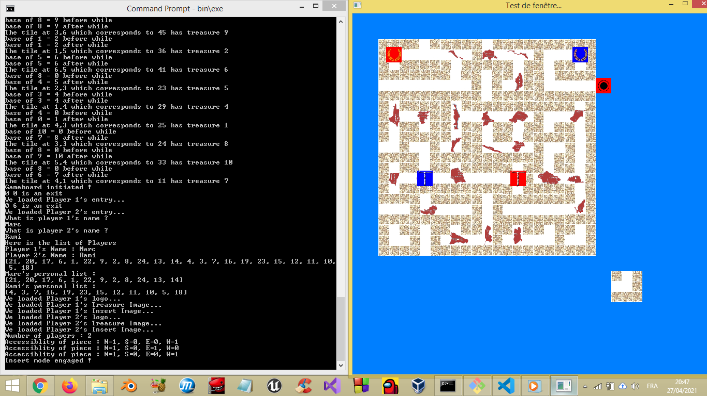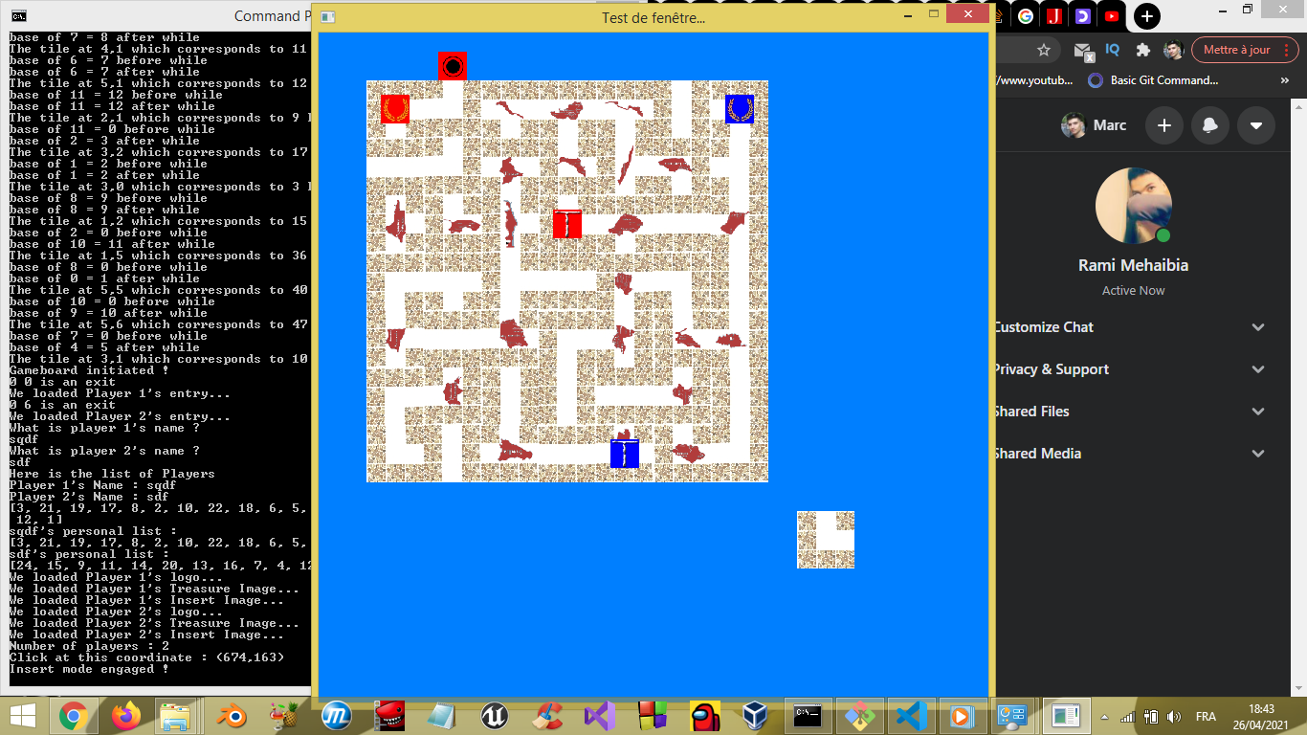

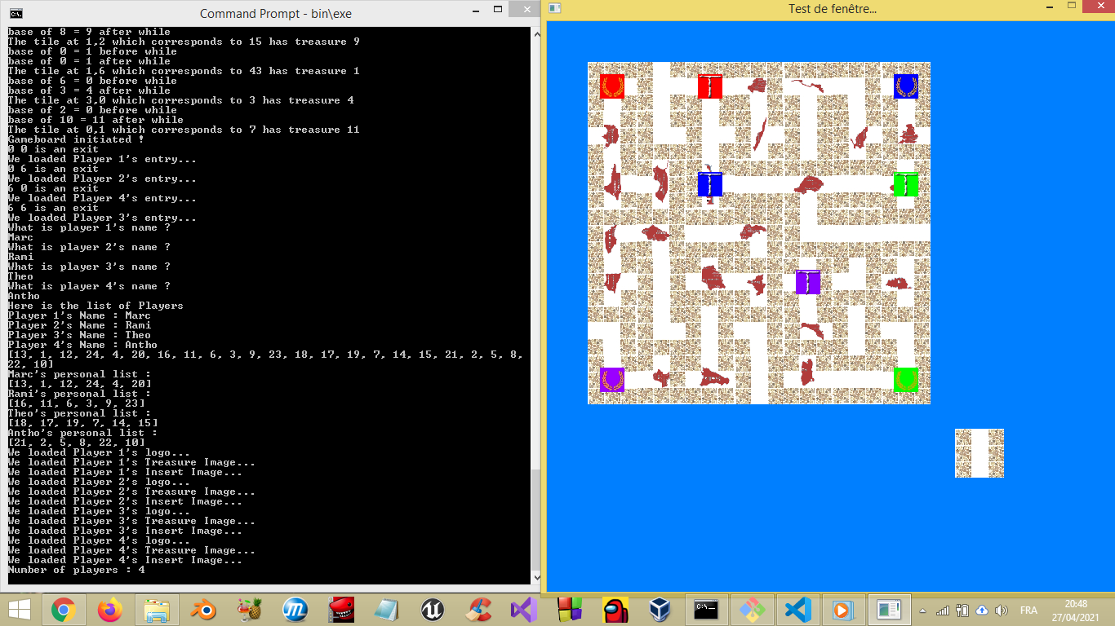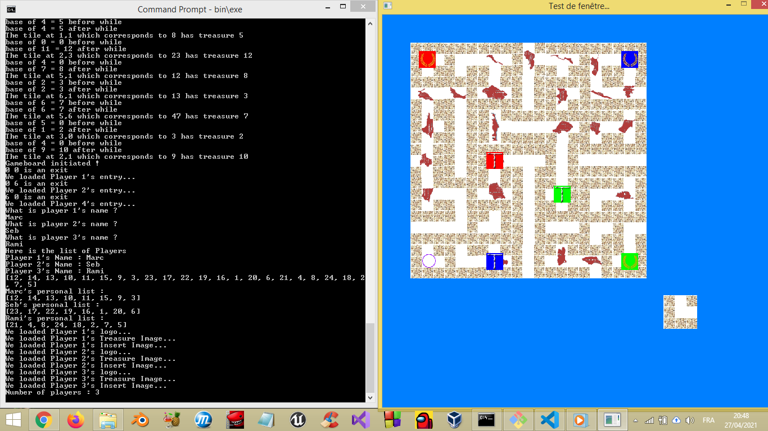

## Audio system nightmare

This was the worst night I had. No sleep whatsoever. None.

This idea came into being by the sole fact that we could “Initiate Audio” in SDL. Turns out, it is only complicated to first grasp it, but then when you get the hang of it and improvise, it’s alright.

But how did we manage to do such a feat? There were three periods during the night of Monday to Tuesday (I think):

* Creation of audio samples and sound effects
* The agony of making it work
* Implementation of every sound effect after it finally worked

Let’s start with the most enjoyable part: The creation of audio. The idea we had in mind was to have a retro kind of Labyrinth game. So I looked for a NES (Nintendo Entertainment System) sound creator and came across a nifty sound editor called Famitracker (<http://famitracker.com/>). In this application you have a sort of timeline and 4 channels (2 Pulse channels, 1 Triangle channel and 1 Noise channel) where we insert notes (in the American system of C D E F G A B C which is the equivalent of Do Re Mi Fa Sol La Si Do) and we can change the speed of the music, its tempo and create new instruments. At the time, I had only a small grasp on how it functioned, but it was just enough to make decent sound effects for the game. Now this application could export the music/sfx you create into WAV form (this detail will be important later on). With Rami we categorised which sound effects we needed and for what action. We also downloaded an audio (which was the first easter egg) for testing purposes and we had it in both WAV form and MP3 just in case.

We did all the sound effects but we now needed to figure out how to make it work into our project. My first attempt of incorporating the sound was by downloading a library extension of SDL called SDL_Mixer. It was supposed to be an easy incorporation but ended up being a waste of time and resources. Maybe if we had more time to think about it we could have incorporated it (because apparently in the long run it was easier and could incorporate any audio format).

Therefore, we turned our heads towards the sub library already available in SDL called SDL_Audio which could only support WAV audio formats. Spoiler warning: it didn’t work the first time. I followed a tutorial on how to make a sound come out of the computer with SDL_Audio functions. And when I tried to press the first button of testing (which was the B-button, the same button where we tried to first have a response out of the computer earlier in our development), no sound came. And instead of being discouraged, I just improvised. I checked how the functions worked and then changed a few pieces of code here and there, and it worked! We had officially a working audio! Well actually not quite. We indeed had a game that could produce sound. But we had a limitation problem that we encountered after pressing repeatedly on the button. It turns out that after a certain limit, the audio did not work anymore. And we found out that each computer has something called “devices”. Each time we performed our audio function, we would use up one of the computer’s devices instead of reusing the one where the first sound came about. I then modified the function so that each time you use it (after the first time) you would liberate the device and the previous audio and so you could then reuse the device all over again. When that finally worked, it was already morning, I was tired as heck, I believe it was around 8 am, and the only thing I could do was to just take a nap, and so I did. I was knocked out up until 16 o’clock but it was worth it. After said nap, I implemented the rest of the sounds and another easter egg for the teacher and invented that Jukebox mode.

## Finishing touches

Alright, by this time we had a working game with audio, now we could add some quality of life improvements to make it more appealing to the players.

First we changed the background from blue to black to not strain the eyes of the players when playing the game. It was quite effective, because I was already feeling better.

Then we created the textures for the title screen and for each player to win. We just used our good ol’ Photoshop for this. Note that we did not put the names of the players, because we did not know them, and we could not generate an automatic name creation for the win screen. However the win would also be written on the terminal and who won.

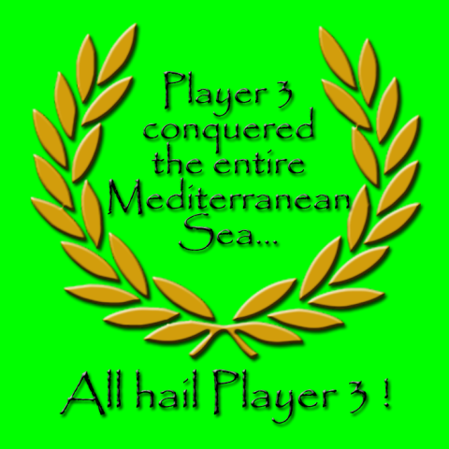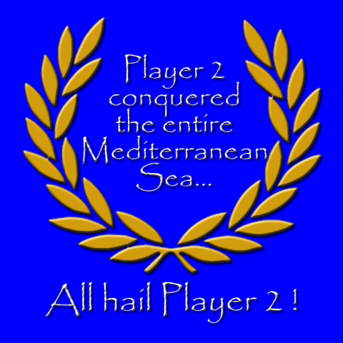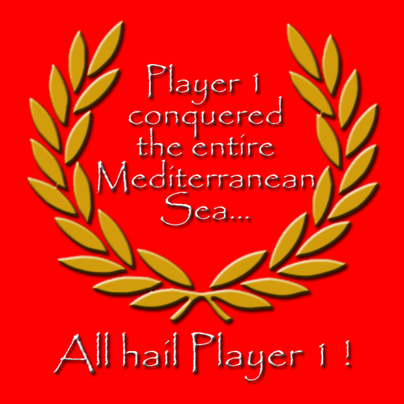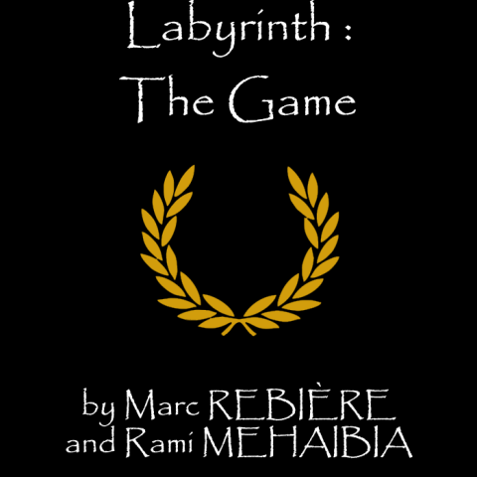

Then, we had to implement something the teacher told us way back when we first started this project: coloured text. The thing is, we used the windows command prompt for Windows 10 or Windows 8 (depending on which computer we worked on at the time), and both can’t change their text colour locally, because it doesn’t recognize some Linux commands fully, and the only thing it could do was change the whole display colour. And that’s when we came across this wonderful terminal called cmder (<https://cmder.net/>) which could do all the Linux functions (as long as you had a good version of mingw32) and even do git functions (and so we could do git pulls and pushes from it). And to top it all off, we could change the colour of the text locally. So why did we bother ourselves to change the colour of the text? It was all for the purpose of having each player get their own colour (P1 Red, P2 Blue, P3 Green, P4 Magenta which was the closest to purple). And after tweaking a bit for each time we printed out something, the code would recognize how to colour the text depending on which player’s turn it was.

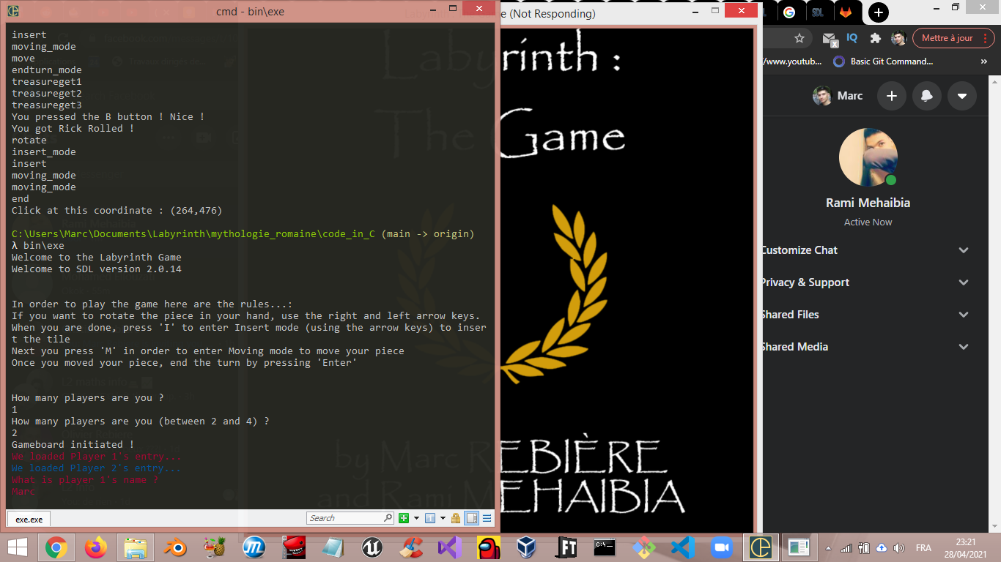

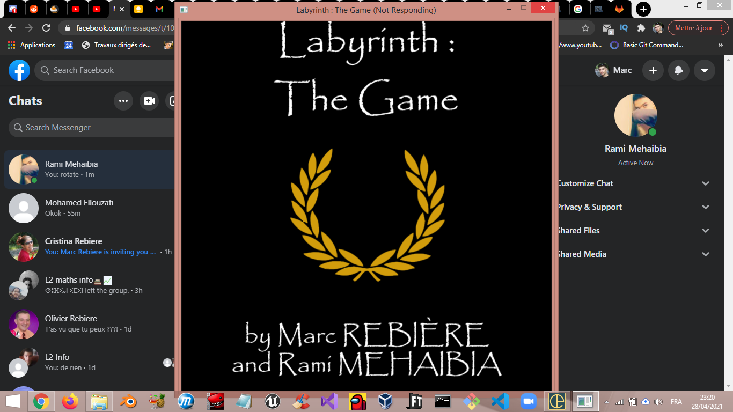

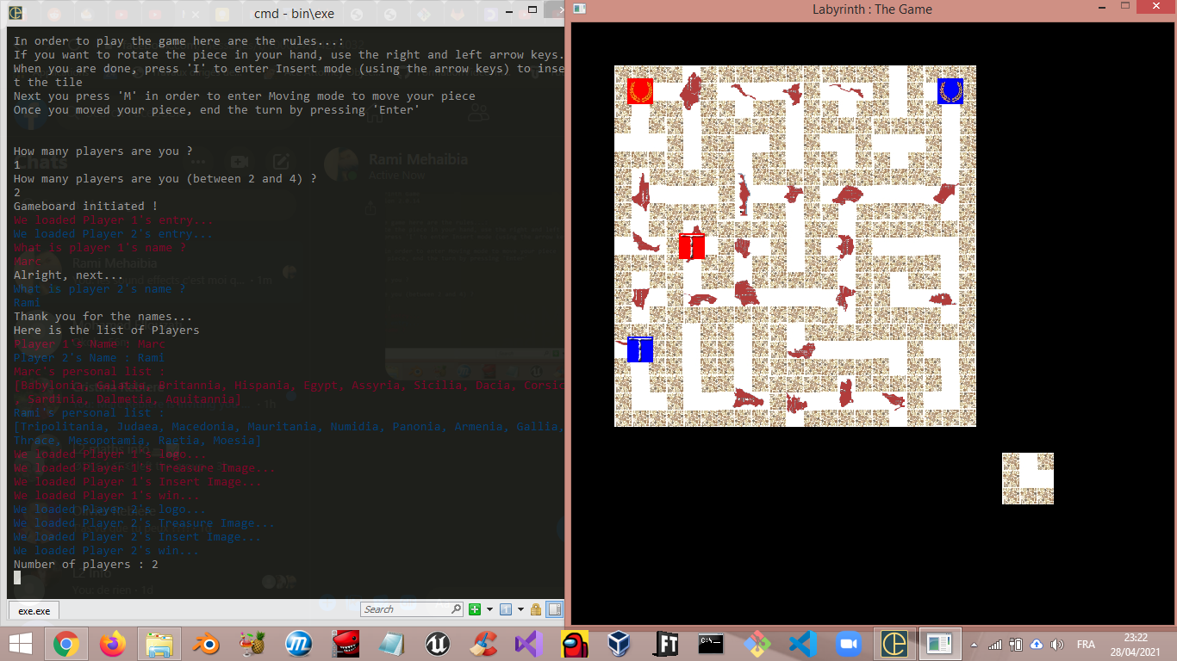

We also made a table of all the lands to conquer and in the same order as the analysis report. And each time it is somebody’ turn we would now tell which land they have to conquer (because we could convert the treasure at the current treasure number of the player into a printable word). Thus instead of printing “Player 1 must conquer 2”, it says “Player 1 must conquer Dacia”.

We also added a print for each time a player conquers a land by telling him or her how many lands are left and if there are none, we just tell him or her that they have to go back to tell their tale or something along those lines.

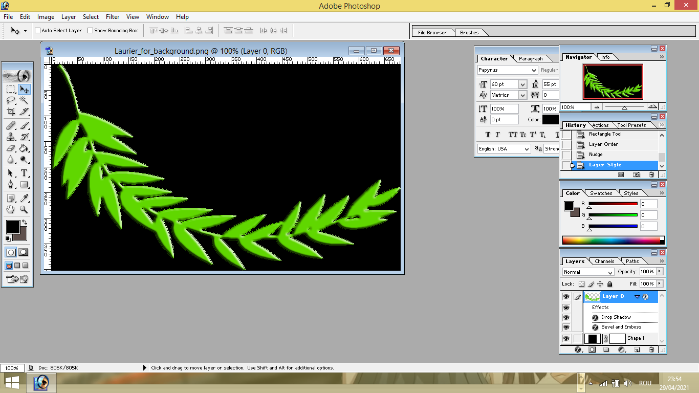 After that, we thought about how to tell visually which player’s turn it was (even though we incorporated this system on the terminal, we went the extra mile for this), and the idea we came up with was to use another laurel coloured by the player’s turn.

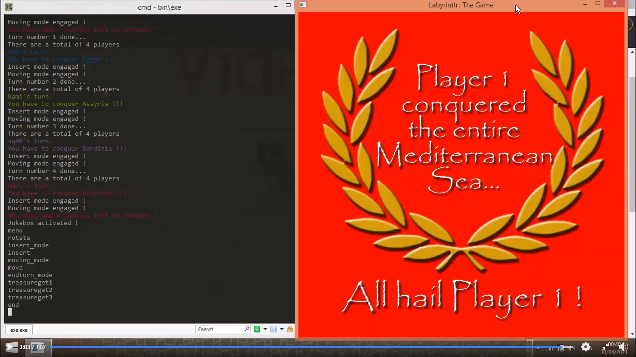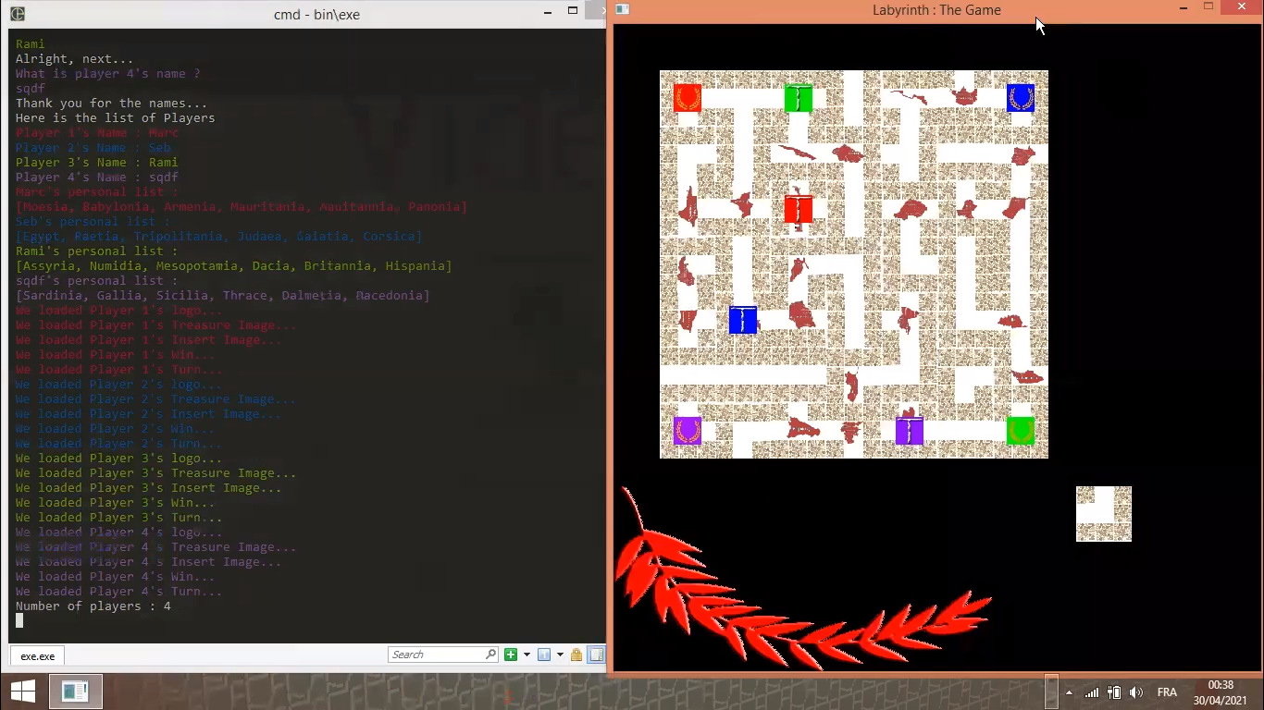



After that, we thought about the fact that the right side felt kind of off because it had blank space. So we decided to fill it up with a roman flag with the player’s turn as a support to tell who’s turn it was.

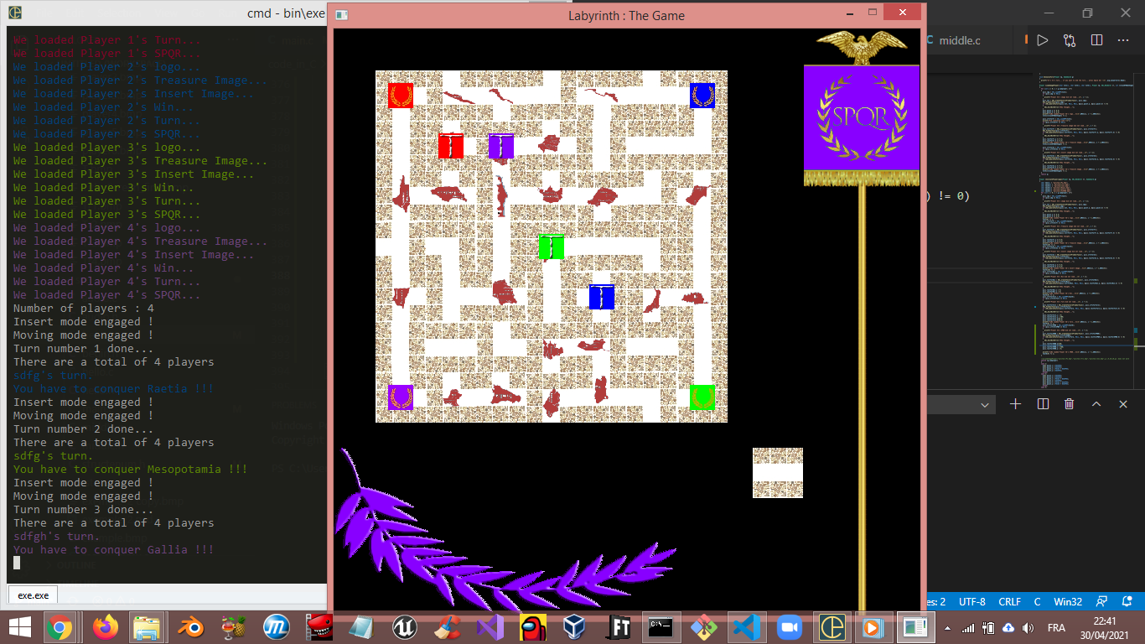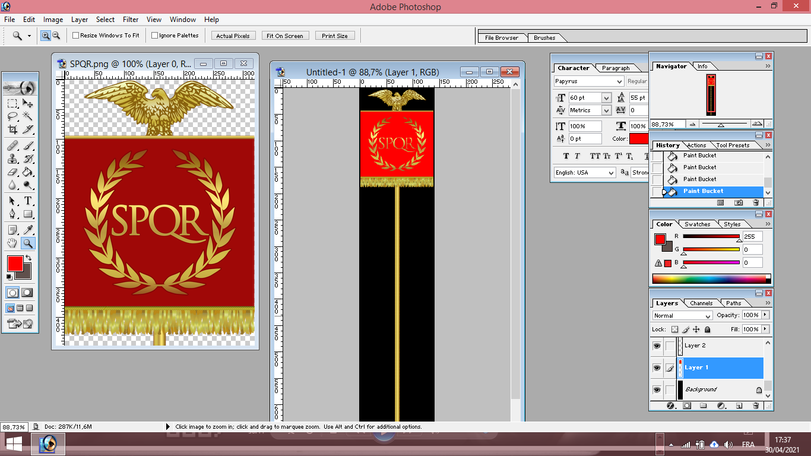

Then, we thought that these flags could have another functionality, but we had to change them a little to make it work.

We had to actually make them bigger to make our new plan work. Those flags’ role changed from telling whose turn it was to the visual amount of how many treasures each player possesses. Each time one player would get a treasure, his or her flag would rise a little more, and when it was fully risen, that meant that you had to go back to your starting point.

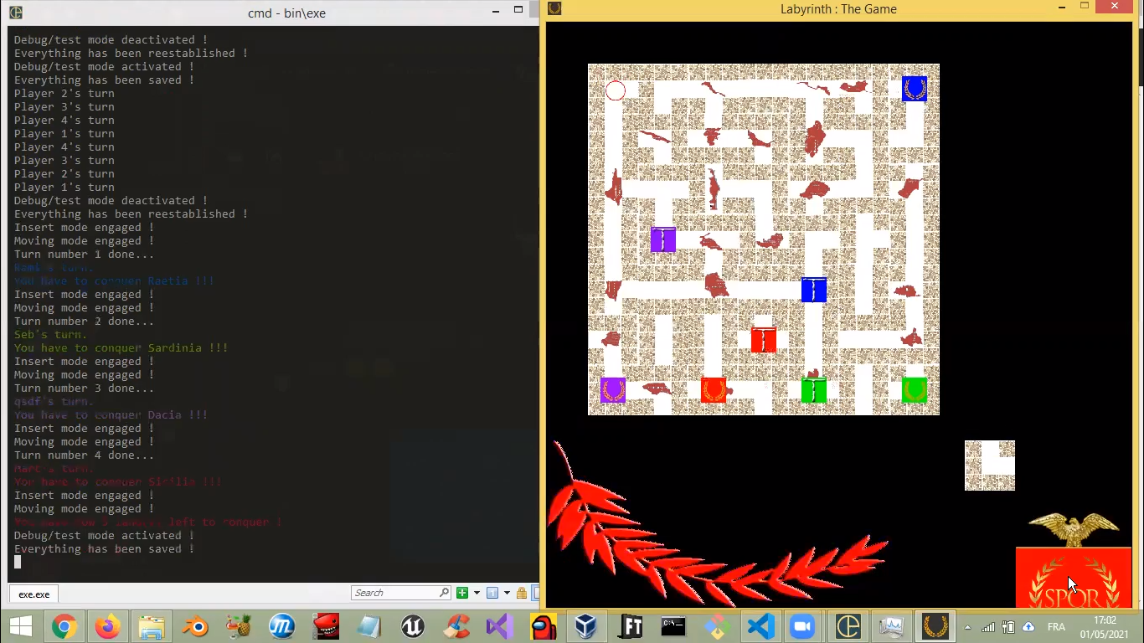 In that time we also developed a Debug mode to test out those functionalities while saving the turns of each player and their number of treasures.

And that pretty much sums up our entire development journey. We will be now talking about our current repository as of the time I’m writing this report.

## How our repository is organized

We have a bunch of folders that each serve a purpose:

* bin : This is where our exectutable resides and where all the dynamic libraries of SDL and SDL_Mixer are
* build : This is where all the .o (object) files reside to build our executable
* include : This is where all the .h (header) files of SDL and SDL_Mixer reside
* lib : This is where the actual libraires of SDL and SDL_Mixer reside
* sfx : This is where our WAV sound files reside… no peeking!
* sprites : This is where all our sprites/textures (aka the BMP files) reside.
* src : This is where our source code resides (it is composed of .c files and .h files)
* test : This is the folder where we tested before how unity worked
* unity : This is where all the unity folders and files reside in.

As for the files residing outside of the folders :

* Implementation report.docx : Inception (there will also be a pdf file once we finish writing this report)
* Makefile : This is a file where we write terminal commands and if we write make or mingw32-make on the terminal, it executes all the commands we have written in it.
* README.md : This is a file where we have written what programs you need to install in order to play this game with links to said sources.
* ref.txt : This is a file our teacher gave us as a reference on how to organize our repositery
* SDLblablabla.gz : This is the compressed folder where our SDL original files reside in case of an emergency

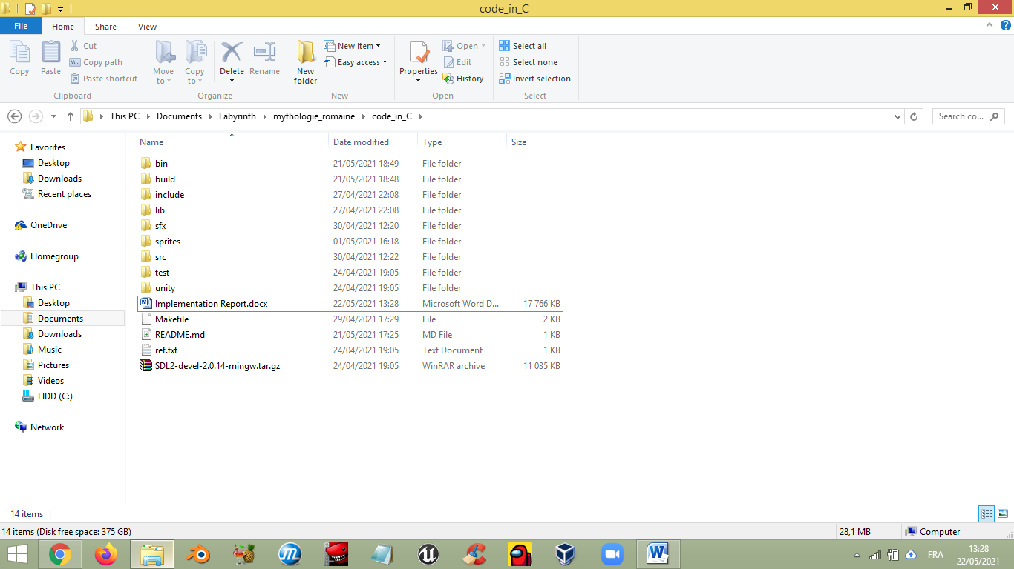

# Conclusion

We had a lot of fun making this game, with some nightmares along the way, but it’s alright because we learned new stuff. Once again we thank our teacher for this project idea (although I wish we had chess, maybe for the guys next year?). We hope that it will not be infuriating to rummage through our code and that you enjoyed reading this 32 page report…

Have a nice day!